Students’ Council President SGBAU, Amravati
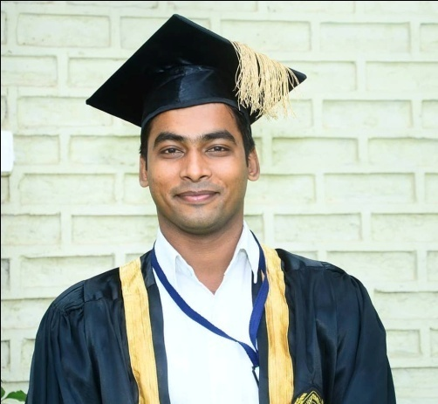

Shri Aniket Anil Ambekar
Students’ Council President SGBAU, Amravati
Email: aniketambekar@hotmail.com
Mob: 9766677755

Shri Chaitanya Hripurkar
Students’ Council Secretary SGBAU, Amravati

Massage by the Students Council President SGBAU Shri. Aniket Anil Ambekar :
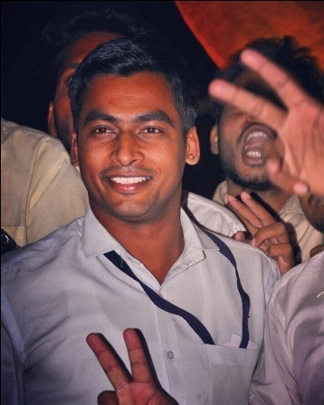

Namaste ……….!
My dear Friends, Ladies and gentlemen,

I am very pleased to be speaking to you today on behalf of the of SGBAU Students’ Council. I hope that you feel as excited as I am to be part of this great moment. I'd like to draw your attention for a few minutes to share with you how important this session is to all of us.
It is honor to speak few words for you all ……….
Who I am …in one sentence ……..I am student like you ….
About our university …….
Sant Gadgebaba Amravati University was established on Maharashtra Day, the 1st May 1983 through partitioning of the University of Nagpur. To cater to mostly the educational needs of rural population of western Vidarbha. The university has its jurisdiction within five districts of Vidarbha viz. Amravati, Akola, Yavatmal, Buldana and Washim.

During my academic studies …….I travel more than 15 universities and 4 Agriculture University in the state of Maharashtra.. I never seen this much cooperative, healthy, student centric environment, like our university …….sant Gadegbaba Amravati University ……Involvement of the student in every perspective of academic and administrative work. Which is required for smooth execution of rights and duties, proper conduct of official work..I experience topmost status provided to every students at every moment while dealing with the student’s development and their problems….

Dear friends, today I would like to share with you a few thoughts…….
According to Swami Vivekananda, it is possible to uplift Indian society from age-old afflictions, responsible for its degenerate conditions, through the process of education alone. The type of education Swami Vivekananda considered most necessary for Indian society is 'man-making education', which would lead to nation-building.
As our universities Mission and Vision it clearly states the Man Making education, which would lead to nation-building.

I would like to remember you all mission and vision of our university ….

VISION : TO EMANCIPATE THE YOUTH FROM THE DARKNESS OF IGNORANCE FOR ELEVATION OF THE SOCIETY BY IMPARTING KNOWLEDGE AND FOSTERING WISDOM AT ITS PLENTIFUL……

MISSION: To contribute to the society through the pursuit of education, learning and research at the highest level of excellence….

This is our university mission and vision, stands to achieve the distinctive profile of India; we have the mission of transforming India into a developed nation.

"Improving all aspects of the quality of education and ensuring excellence of all so that recognized and measurable learning outcomes are achieved by all, especially in literacy, numeracy and essential Life skills."

It is strongly contended that man-making education is to be purposive and free from narrowly conceived objectives. Education should be for all and it should involve a continual growth of personality, steady development of character and the qualitative improvement of life. Education should not involve simply the stuffing of the brain, but the training of the mind.

On behalf of my council and all the students of Sant Gadegaba Amravati University … we demand and what we want ……….?

"We want that education by which character is formed, strength of mind is increased, the intellect is expanded, and by which one can stand on one's own feet.

We strongly believe "Our Teachers, Our Heroes".
“My message, especially to students and my dear friends, you have courage to think differently, courage to invent, to travel the unexplored path, courage to discover the impossible and to conquer the problems and succeed. These are great qualities that you must work towards.”
Still, I and my council have short tenure, but I promise you all will do constructive work for the development of students and focus on quality education.
Once again, let me congratulate all the members. My best wishes to the students and Sant Gadgebaba Amravati University Amravati for success in the mission of developing qualitative and technological human resource for the nation.

Thank you very much Ladies and Gentlemen.

JAI HIND…….!

Photo Gallery:
